**Regular Expression**

Assignment 1

**COMSATS University Islamabad**

Sahiwal Campus

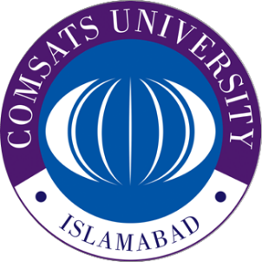

**Usama Sarwar**

FA17-BS(CS)-090-B

**Mr. Yawar**

Automata Theory

February 25, 2020